Nathan Berger

Output Module 2

Script 1 Output

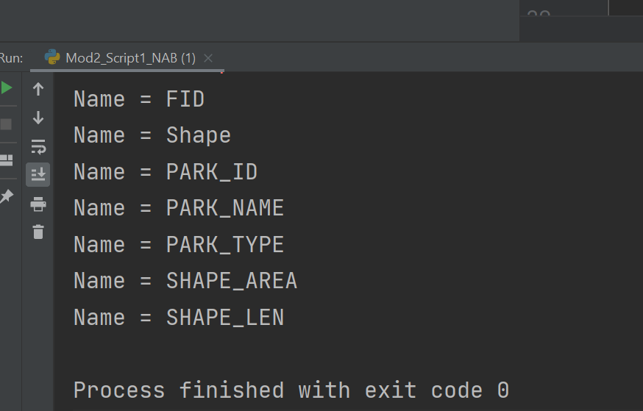

Script 2 Output

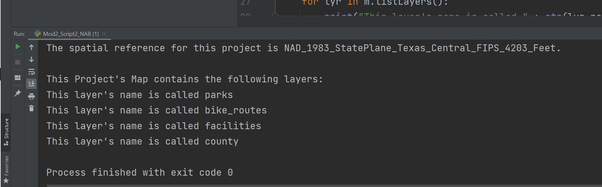

Script 3 Output

